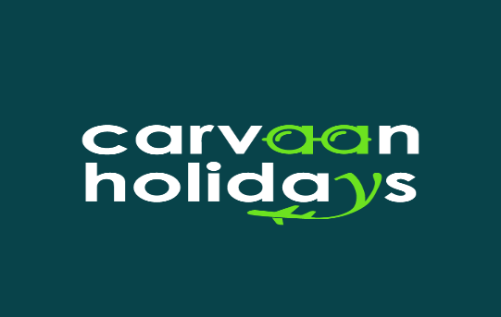 | CARVAAN HOLIDAYS  SHOP NO. G -3 PLOT NO. 12, HDB ARCADE DURSANCHAR NAGAR, SHAHPURA BHOPAL - 462026  Email: info@carvaanholidays.com – Phone: +91 9131978160  Website: https://www.carvaanholidays.com

Ref. Query ID: CH09121112 | Date: 09 Dec 2025
GUJARAT (3N 4D)

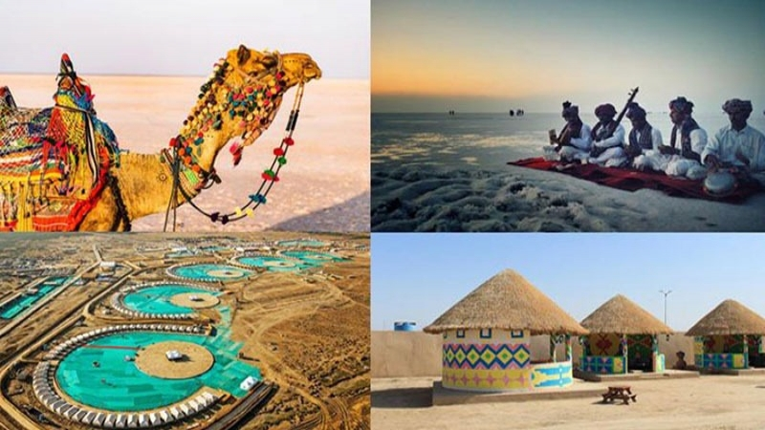

QUOTE DETAILS
Visit Places | Rajkot/ Ahmedabad – Dwarka – Somnath – Ahmedabad/ Rajkot Drop
Travel Date | 11 Dec 2025 | Total Days | 4
Total Passenger | 2 Adults | Quote Include | Hotels, Vehicles

SHORT ITINERARY

DAY 1: ARRIVE AHMEDABAD (8Hrs) / RAJKOT (4.5 Hrs) – DWARKA

DAY 2: DWARKA – BET DWARKA – DWARKA

DAY 3: DWARKA – SOMNATH

DAY 4: SOMNATH – RAJKOT (4.5Hrs) / AHMEDABAD (7.5Hrs) DROP

HOTEL DETAILS:

OPTION: 01

TOTAL PACKAGE COST ₹
Cost Per Person | INR 17,500/- X 02
Total Cost | ₹35,000/-

ACCOMMODATION STANDARD*

DESTINATION | HOTELS | ROOM TYPE | CHECK-IN & CHECK-OUT | NO. OF NIGHTS
Dwarka | Hotel The Grand Dwarika | Executive Deluxe | 11th – 13th Dec, 2025 | 02
Somnath | Clarks Collection | Deluxe | 13th – 14th Dec, 2025 | 01

OPTION: 02

TOTAL PACKAGE COST ₹
Cost Per Person | INR 19,500/- X 02
Total Cost | ₹39,000/-

ACCOMMODATION 3*

DESTINATION | HOTELS | ROOM TYPE | CHECK-IN & CHECK-OUT | NO. OF NIGHTS
Dwarka | Hotel Vits Devbhumi | Executive | 11th – 13th Dec, 2025 | 02
Somnath | Vits Somnath Gateway | Elegance | 13th – 14th Dec, 2025 | 01

DETAILED ITINERARY:
DAY 1: ARRIVE AHMEDABAD (8Hrs) / RAJKOT (4.5 Hrs) – DWARKA
• Arrive Ahmedabad/ Rajkot
• Dwarkadhish Temple
• Rukmani Devi Temple
• Gomti Ghat
• Gopi Talab
• Overnight stay at Dwarka

DAY 2: DWARKA – BET DWARKA – DWARKA
• Nageshwar Jyotirlinga Temple
• Bhadkeshwar Mahadev Mandir
• Sudama Setu (Sudama Bridge)
• Shri Swaminarayan Mandir
• Beyt Dwarka Temple
• Overnight stay at Dwarka

DAY 3: DWARKA – SOMNATH
• Somnath Jytorilinga Temple
• Bhalka Tirth
• Madhavpur Beach
• Pandava Gufa
• Lord Laxminarayan Temple
• Triveni Sangam
• Overnight stay at Somnath

DAY 4: SOMNATH – RAJKOT (4.5Hrs) / AHMEDABAD (7.5Hrs) DROP
• After breakfast checkout from the hotel
• Drop at Rajkot/ Ahmedabad

TOUR ENDS BUT SWEET MEMORIES ALWAYS REMAINS SAME

SPECIAL INCLUSIONS:

- Accommodation at the hotels mentioned or similar on MAPAI basis.
- 01 Room on Double sharing basis
- 03 Breakfast & 03 Dinner Mandatory at Kutch
- All Transfers & Sightseeing by a Pvt Air-conditioned vehicle AC Sedan
- Toll charges, Parking, Driver Allowance & Fuel Cost
- All rates are inclusive of Government Tax (GST 5%)
- 24*7 assistance from Carvaan Holidays

TOUR EXCLUSION:

- Entrance Fee to any sites.
- Early check in or late check-out charges.
- Tips to Guides / Chauffeurs
- Lunch, Dinner or any extra meal not mentioned on the above inclusions /program during the tour.
- All items of personal nature.
- Any service not specifically mentioned in the inclusion

HOTEL/LAND CANCELLATION POLICY:
- Date of booking to 30 days before travel the cancellation charges will be 25% of the tour cost (During Season) &Nill (During Off-Season)
- 30 to 15 days before the trip - cancellation charges will be 50% of the tour cost (During Season) & 25% (During Off-Season)
- 15 to 7 days before travel - cancellation charges will be 75% of the tour cost (During Season) & 50% (During Off-Season)
- 0 to 7 days before travel - cancellation charges will be 100% of the tour cost. No refund shall be given
- Please Note: Cancellation policy is subject to change. It depends on the hotel policy.
- In peak season (example: long weekends, festival season, summer vacation, etc.) most of the hotels charge 100% cancellation.
For more information about cancellation policies, please contact our sales/reservation executive.

PAYMENT POLICY:
50% of the total amount should be paid at the time of booking and the balance amount to be paid on or before 30 days of travel date.

BANK DETAILS:

ACCOUNT Name - Carvaan Holidays
Account No. - 327105500026
IFSC Code - ICIC0003271
Account Type - Current

REFUND AND CANCELLATION POLICY:

Carvaan Holidays believe in helping its customers as far as possible, and has therefore a liberal cancellation policy. Under this policy:
- Any Reservation cancelled before 45 days there will be fully refunded.
- Any Reservation cancelled between 30 days there will be 50% refunded.
- Any Reservation cancelled between 15 days there will be no refunded.

